[ FODDIE ]

**Project Progress Report**



**Department of Electrical and Computer Engineering North South University CSE 299: Junior Project Design**

**Group Member:**

**1. Md. Ahasun Kamal (1530187042) 2. Sifat Anwar(1812887642)**

**TABLE OF CONTENT**

1. **PROGRESS & ACHIEVEMENTS**
2. **OBSTACLES**
3. **MILESTONES & REPORTING**

**1.PROGRESS & ACHIEVEMENTS**

Both team members worked together to:As part of Stage-5 of our timeline submitted in Progress report-6.In this section we design home page and connect to data base with php.in week 4 one group member sifat anwar(1812887642) creat sign up page and another group membar ahasanul islam (1530187042) create login page.in this week I desing home page

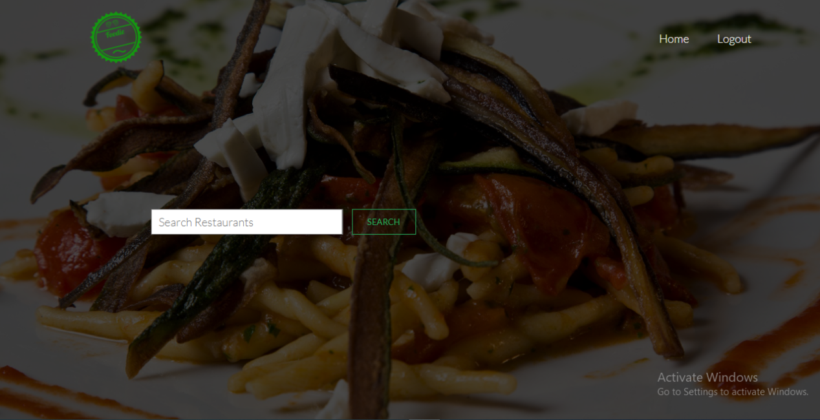

Aftar login user he go to this page.he can choose his following resaurantn in bellow.we add some functionally in next week.

**2.OBSTACLES**

In this section we found some problem this page .and also last login and singup page. We fixed login and sign up page problam.

# 3.Milestone and reporting

According to our original Project Proposal, we have completed Stage-6 of our timeline. The team will start working on Stage-7immediately.

|  |  |  |
| --- | --- | --- |
| **Milestone** | **Tasks** | **Date** |
| Week-1 | Project idea and proposal | 03-07-2021 |
| Week-2 | New language learning and codinng standerd | 11-07-2021 |
| Week-3 | Design work plan | 18-07-2021 |
| Week-4 | Create database | 25-07-2021 |
| Week-5 | User case daigram | 07-08-2021 |
| Week-6 | Add factionality | 15-08-2021 |
| Week-7 | Create GUI | 20-08-2021 |
| Week-8 | Database connection | 27-08-2021 |
| Week-9 | Progress Report Due | 02-09-2021 |
| Week-10 | Final presention | 05-09-2021 |
| Week-11 | Final report(thesis) | 12-09-2021 |